MGMS – User Management

Functional Specification Document

Ver 1.4

Version History
Version # | Date | Description
1.0 | 20-Oct-2010 | First Draft
1.1 | 05-Nov-2010 | Added validation check – error messages
1.2 | 07-Dec-2010 | Added Password Rules

Table of Contents

Version History 2
1 Introduction 4
1.1 Purpose 4
1.2 Scope 4
1.2.1 Add user 4
1.2.2 Project Permission 5
1.2.3 Access Permission 5
1.3 Assumptions 5
1.4 Constraints 5
2 User Management 5
2.1 Users List 6
2.2 Project Permission 7
2.3 Access Permission 8
2.4 Role Privileges 9
3 Business Rules 10
4 Status Messages 10

Introduction

Purpose

This document provides the requirements and functional specifications for the User Management module in the Multisite Grant Management System project.
This is not a project plan or a design document. It is a guide for system architecture and development, not for phasing, timelines or deliverables.
Finally, this is a ‘living document’ and the specification will change, continuously, as the project proceeds. More details will be added and the existing information edited as the requirements, scenarios and use cases evolve in the course of the project.

Scope

Add user
Using this functionality, the institution site admin can create any number of new users for the GMS.
- The details saved for this profile will be – Full name, password, email and role in the institution
- A confirmation email with the activation link and login details will be sent to the email address entered during registration.
- Account will get activated by clicking the activation link provided in the email.
- There will be an option for the user to change the login password. If the user forgets the password, the system will reset the password and send it to the email entered by the user based on request.
- A user accessing the GMS using the login created by an institution’s site administrator will have privileges and permissions corresponding to the role chosen and the access will also be only to that particular institution’s GMS.
Currently a single user cannot use the same access for multiple institutions. He will have to use separate usernames and passwords to log into each of the institutions.
Currently the user profiles have not been linked to the employee profiles for each of the institutions.
Currently, the role once assigned to a user, cannot be modified and only a single role can be taken by a user.

Project Permission
In this section, a new user may be given access to a number of projects all at once, by simply selecting the projects. Once they are selected, the user can view his list of projects when he logs into the GMS.
Currently, each user can view and edit only projects in the institution to which he has logged in.

Access Permission
This functionality will enable the site administrator to create and customize sets of privileges/privilege groups for each role created for the institution.
The advantage is that, when a role is chosen for a new user, he is automatically & immediately given permissions and rights corresponding to the role.
There is a further provision to assign all of the privileges in the GMS to a specific role (aside from that of site admin), using a single click.

Assumptions

The users are unique to the institutions i.e. a user does not belong to more than one institution.
The users of this application are not regular employees of the respective institutions. Currently the employees do not have access to the application.

Constraints

Requirements clarification needed (and awaited for) as to the relationship between users and employees. Clarification is required also for the users and employees’ association with individual or multiple projects, institutions etc.

User Management
- The details saved for each user are – Full name, password, email and role in the institution
- A confirmation email with the activation link and login details will be sent to the email address entered during registration.
- Account will get activated by clicking the activation link provided in the email.
- There is an option for the user to change the login password. If the user forgets the password, the system will reset the password and send it to the email entered by the user based on request.

Users List

Figure 1: User List
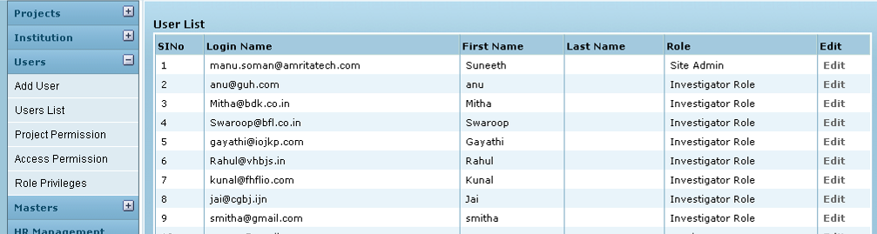

Field /Label | Input-Control | Data Type | Remarks /db table > field
User List
SlNo | Auto populated
Login Name | Auto populated | String
First Name | Auto populated | String
Last Name | Auto populated | String
Role | Auto populated | String
Edit | “Edit” Button

Edit User

Figure 2: Edit user
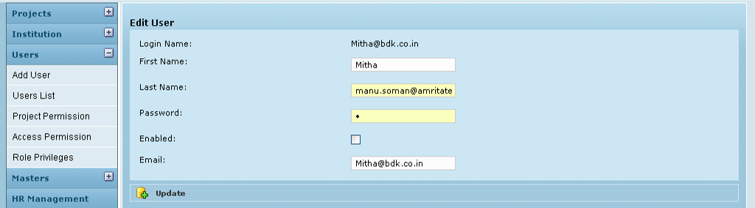

Field /Label | Input-Control | Data Type | Remarks /db table > field
Edit User
Login Name: | auto populated | String
First Name: | Textbox; auto populated & editable | String
Last Name
Password: | Textbox; auto populated & editable | String
Enabled: | Checkbox | bit(1)
Email: | Textbox; auto populated & editable | String
Update | Button

Project Permission

On click the Project Permission tab in the menu list, the screen for giving project access permission will appear. The projects can be viewed /accessed only by the site admin who created those projects.

Here, a new user may be given access to a number of projects all at once, by simply selecting the projects.
Once they are selected, the user can view his list of projects when he logs into the GMS.

- Select the user from the list.
- The siteadmin can assign or unassign the projects to the users by clicking the appropriate direction button.
- To assign the projects select the needed project and click the arrow button towards right hand side and to unassign the projects click the arrow button towards left hand side.

Figure 3: Create Project Permission
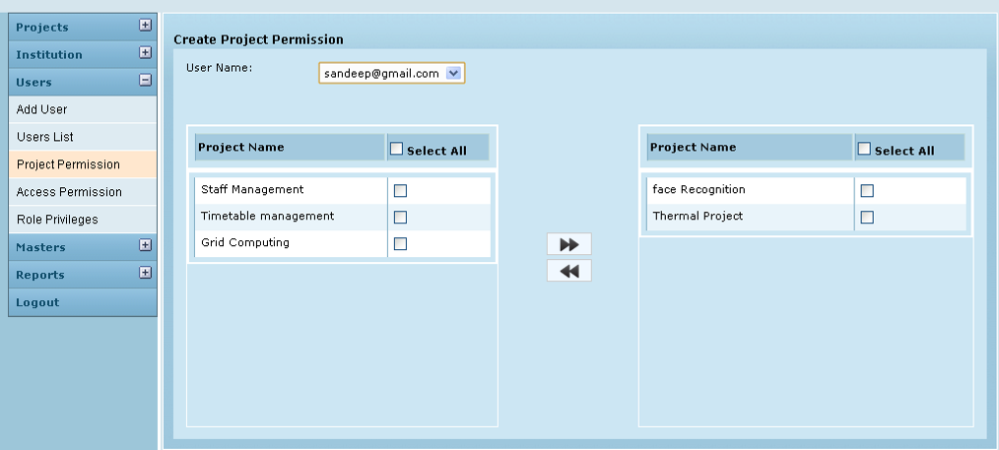
1
2
3
4

- The project which is already assigned to that particular user will be listed in the right hand side.
- The projects which are not already assigned to that particular user will be in the left hand side.

Field /Label | Input-Control | Data Type | Remarks / db table > field
Create Project Permission
User Name: | Listbox | String
Project Name | List | String
Select All | Checkbox
Label 1 | Checkbox | To select /unselect each unassigned project
Label 2 | Right arrow | To assign the projects select the needed project and click the arrow button towards right hand side and to unassign the projects click the arrow button towards left hand side.
Label 3 | Left arrow
Label 4 | Checkbox | To select /unselect each assigned project

Access Permission

On click the Access Permission tab in the menu list, the screen for giving access permission will appear. The site admin can give privileges on each action to the users on the basis of roles.
This is done with the help of ACL plug in.
The site admin can allot the projects to any other users created by that siteadmin.

Figure 4: Create Access Permission
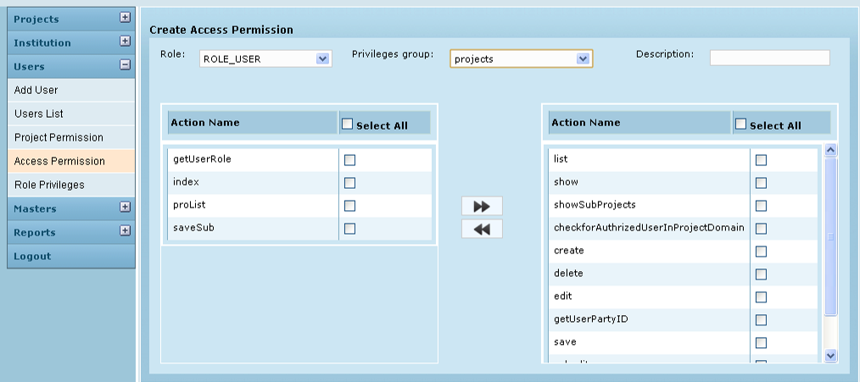
1
2
3
4

The actions under that privilege group on which the selected role had access will be listed in the right hand side
The actions under that privilege group on which the selected role had access will be listed on the left hand side.

Field /Label | Input-Control | Data Type | Remarks / db table > field
Create Access Permission
Role: | Listbox | String
Privilege Group | Listbox | String
Description | Textbox | String
Action Name | List | String
Select All | Checkbox
Label 1 | Checkbox | To select /unselect each unassigned action
Label 2 | Right arrow | To assign the projects select the needed action privilege and click the arrow button towards right hand side and to unassign the action privilege click the arrow button towards left hand side.
Label 3 | Left arrow
Label 4 | Checkbox | To select /unselect each unassigned action privilege

Role Privileges

Selecting a role and clicking the create button will give all the privileges to that role.
Field /Label | Input-Control | Data Type | Remarks / Edit Check
Create Role Privileges
Authority Name | Listbox | String
Create | Button

(Make sure that before giving all privileges, that role has no access on any action.)

Figure 5: Create role privilege
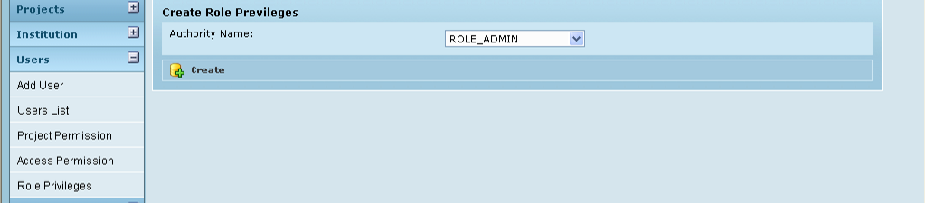

Business Rules

- Access control is role based
- Any number of actions may be assigned to a privilege group.
- Any number of privilege groups may be assigned to a role.
- A user may be given permission to access any number of projects in the institution
- Password Creation rules:
Password should:
  - Be 6-12 characters long
  - Have at least 1 alphabet
  - Have at least 1 numeric value
  - Have no special characters
- Each user can be assigned only a single role in his institution.

Status Messages

Sl No | Status Message
1 | Created Successfully
2 | Updated Successfully
3 | Deleted Successfully
4 | The Requested Record Not Found
5 | The Record can't be deleted, Already in use
6 | The Record Already Exists
7 | Please Enter a valid email address
8 | You can not delete yourself, please login as another admin and try again
9 | User Map already exists
10 | User Mapped to Project
11 | User Already Mapped to Project
12 | Please Select Role
13 | Incorrect Entry!!!!!!\r\r\Please Start with 'ROLE_'

